

INVESTMENT PROPOSAL

Prepared for
Mr Example

Prepared by Advisor

Date May 2020

Mr Example

5 May 2020

Dear Mr Example

INCOME FROM PORTFOLIO

The primary purpose of the investment plan is to provide an income strategy that will provide you with an income for the rest of your life.

Our advice process is based on timeless investment principles which have stood the test of time. We continually do research on investment theory to ensure that our advice and value proposition to you remain relevant and offer the best possible solutions taking risk and return into account.

Regards

_______________
Advisor
Wealth Manager

Goals & requirements

- Retirement – Immediate
- Income required – R110 000 pm after tax
- Additional withdrawals – R150 000 pa for travel
- Increase in income – Inflation linked
- Projection term – 30 years
- Additional requirements – R950 000 emergency fund

Assumptions:
- Average tax rate of 30%
- Inflation of 4.5% in income solution projections and 5.5% in cash flow projections
- Advice fees of 0.58% (incl. VAT) and LISP fees of 0.35% (incl. VAT)

Capital available

Description | Amount
PPS Retirement Annuity 1 | 3 141 418
PPS Retirement Annuity 2 | 3 578 591
FNB Investment | 950 000
Glacier Global Life Plan 3 ($650 825 @ R15) | 9 762 375
Glacier Investment Plan 4 | 6 363 695
Glacier Investment Plan 5 | 1 315 638
Glacier Investment Plan 6 | 2 786 490
Glacier Vantage Life Plan 7 | 516 709
Glacier Vantage Life Plan 8 | 328 739
Glacier Vantage Life Plan 9 | 734 459
Glacier Vantage Life Plan 10 | 577 094
Investec Share Portfolio 11 | 6 396 010
Investec Share Portfolio 12 | 1 048 824
PPS Vested Profit Share Account 13 | 667 156
Proceeds from sale of business | 8 000 000
Less: Emergency fund | -950 000
Total | 45 217 198

Current portfolio structure

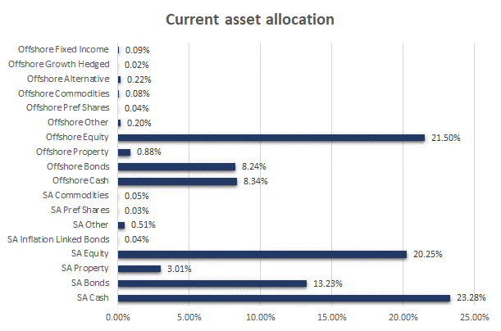
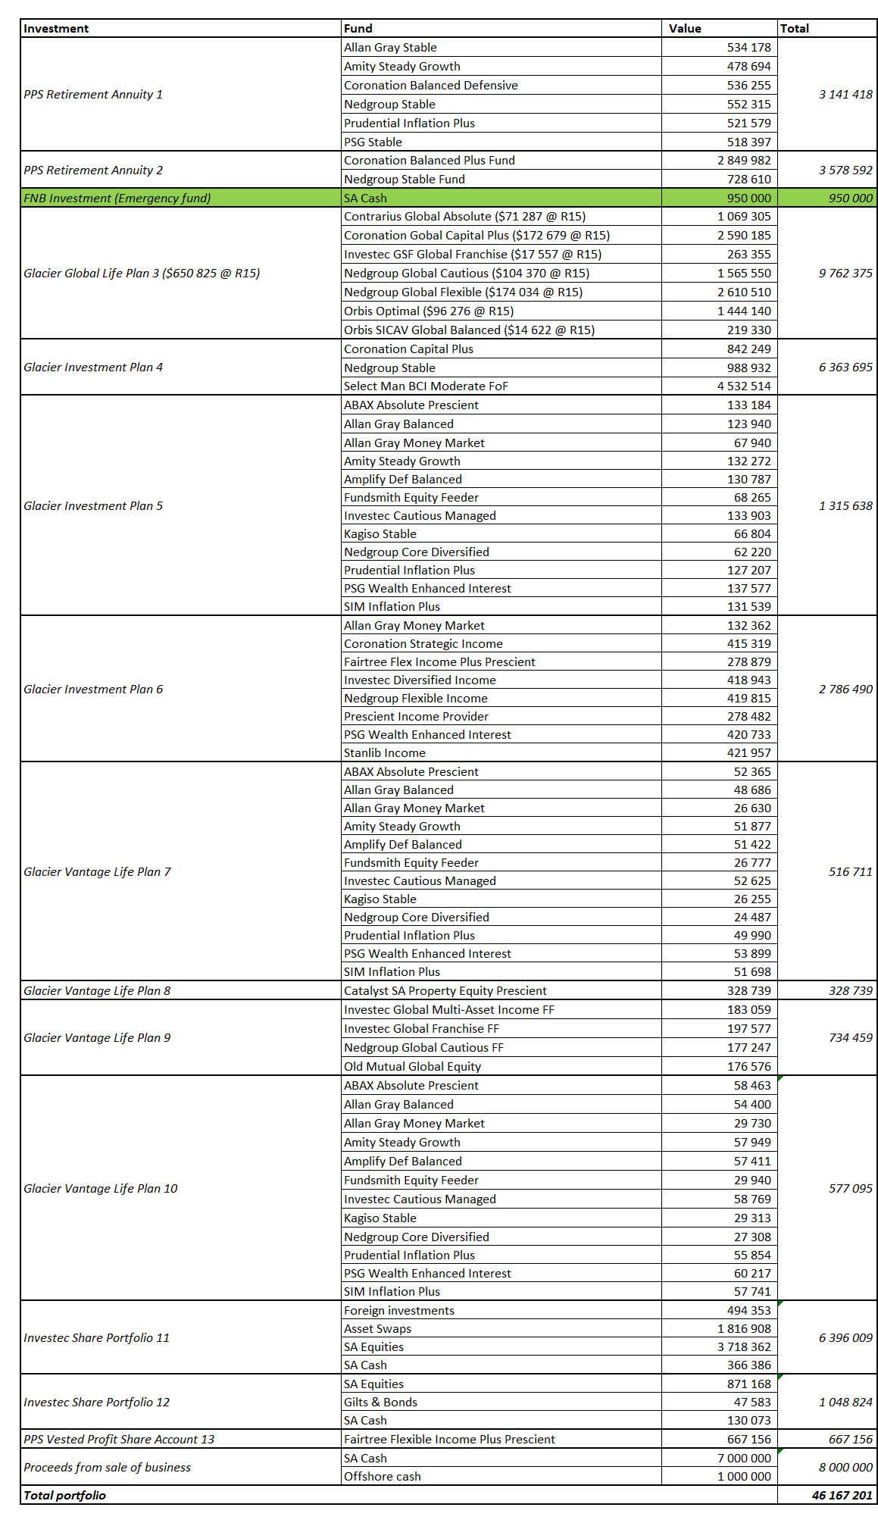

Investment strategy options & outcomes

We considered the following strategies:

- Making use of a bucket approach to provide you with an income. In this strategy we will be making use of outcomes based solutions to reach the goals in each bucket.
- The same strategy as in point 1, with the difference of placing the first 5 years’ income in a guaranteed income plan, while the balance of the portfolio is structured for growth over the medium to long term.

Below are the outcomes of each of the above strategies. Bear in mind that no figures can be guaranteed and that certain assumptions were made. As projections are done over a long period, there are many factors that can affect the outcome. We also know that personal circumstances and needs can change. It is therefore very important to review your portfolio at least once a year so that any such changes can be considered.

The actual fund allocations or split of the capital will be discussed under section 5.

Option 1 – Bucket approach using outcomes based solutions

The capital from your retirement annuities will be transferred to a living annuity and placed in an income solution. The proposed portfolio is the Inflation Protected Income Solution, which aims to generate an income that can keep up with inflation over time, while protecting your capital in real terms.

Inflation Protected Income

- Income growing with inflation
- Capital growth

For the discretionary capital the idea behind this approach would be to invest the first 3 years’ income in a portfolio that focuses on generating the highest level of income and although there may be small up and down movements in the value of the capital, the volatility should be fairly low.
Stable Income

- High starting level of income
- Stable income
- Stable capital

In the above, it is important to remember that you will be drawing capital as well, and that the stable capital refers to the up and down movements in the pricing of the units held. The stable income stream refers to the income generated per unit that is expected to be stable.

The balance of the portfolio will be structured making use of outcomes based solutions as indicated in the illustration below:

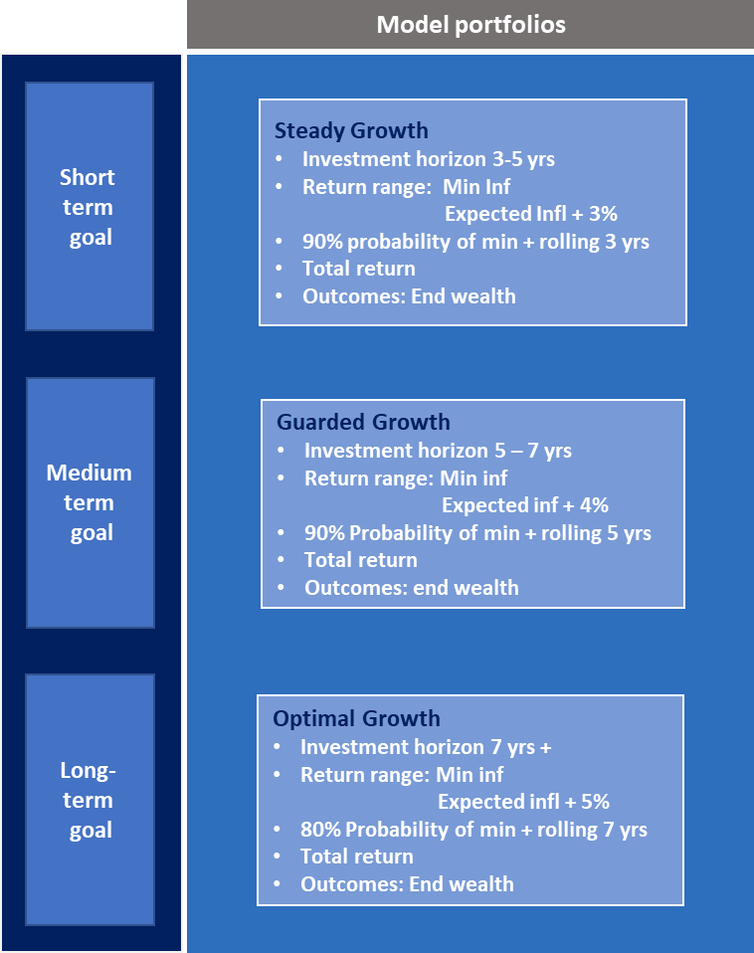

The capital that will be allocated to the Optimal Growth strategy under your long-term goals, will be the balance of the capital after setting aside your existing direct offshore investments, as well as the allocation required to the other solutions to meet the short- and medium term goals.

Projections

The projection for the capital in the living annuity is set out in the graphs below:

Important note:
Due to the Covid-19 outbreak and other economic factors, we currently find ourselves in a very different market environment than expected a year ago. Although the fundamentals of the solution proposed below still remain, we adjusted the figures used in the projection tool to reflect a more realistic picture of the expected income stream for the next few years, based on the current market climate. The expected income produced and the increases in this income over the next few years may therefore be lower than inflation. This is reflected in the graphs and is applied over the full projection term. However, it is still expected that the income produced will keep up with inflation over the long term. This is backed by intensive research conducted on the solution. The figures in the projection tool will therefore be updated on a quarterly basis to continue to provide a realistic picture of what can be expected in the initial years after investing.
Amount invested | Living annuity – R6 720 009
Income produced | Living annuity – R35 307 pm  Assumption of 2.5% increase per year
Income drawn | Living annuity – R27 104 pm before tax (R18 973 pm after tax)  Income drawn to increase with 4.5% per year
Increase in income | For the next few years, the increase in income produced is expected to be lower than inflation. The projections assumed a growth of 2.5% against inflation of 4.5%. As you will be drawing less income than the solution is expected to produce, you should only start drawing more income than the portfolio produces after about 25 years, if the growth in income produced is kept at 2.5%.
Capital | Although it is expected that the capital should keep up with inflation in real terms over the long term, the adjusted assumptions (based on the current market environment) show an increase in nominal terms, while the capital decreases in real terms.

Income produced vs income need

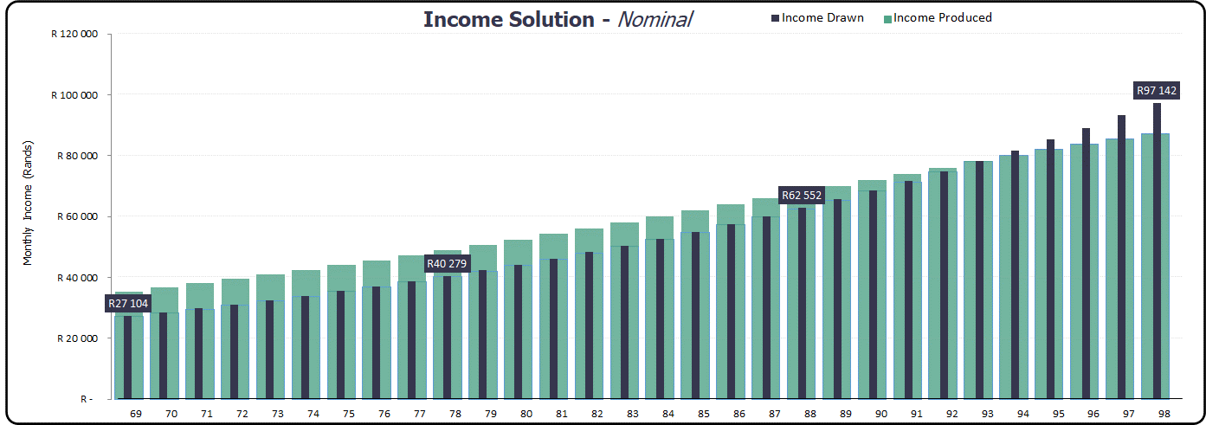

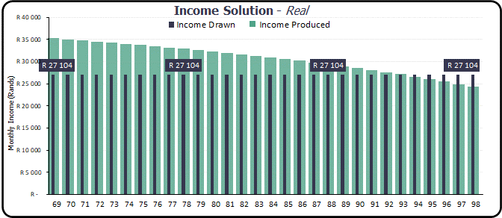

Capital value

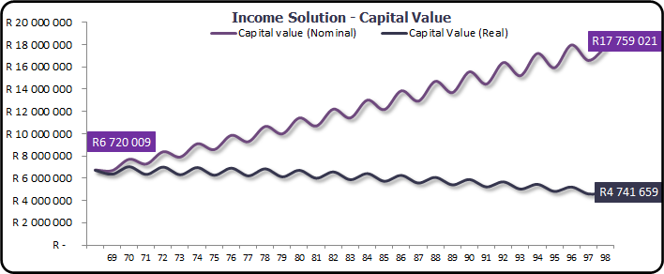

The below projection graphs for the bucket approach followed in the discretionary capital, assumed the following allocation to each solution:

Solution | Years’ income | Yield %  (after advice & platform fees
Stable income | 3 | 6.57
Steady growth | 3 | 7.57
Guarded growth | 5 | 8.57
Optimal growth and offshore | 10 | 9.57

Withdrawals will be made from the stable income solution.

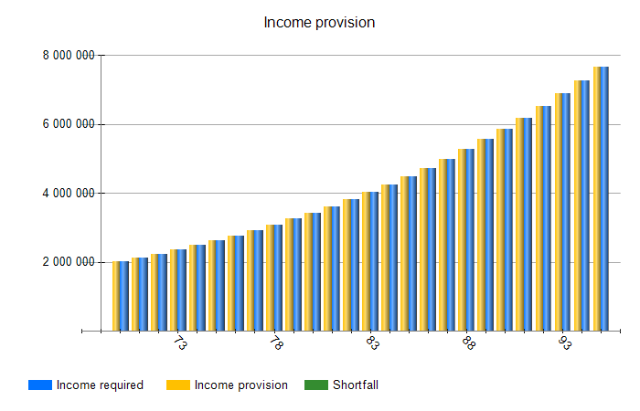

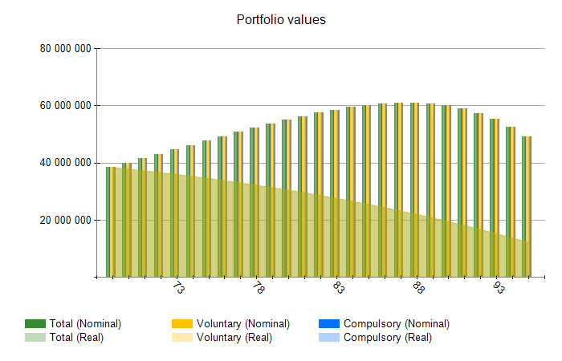

Cash flows are attached separately.

Option 2 – Bucket approach with guaranteed income plan

Although this option is similar to option 1, the difference is that the first five years’ income will be provided by a guaranteed income plan. This means that the Stable Income and Steady Growth options listed under option 1 above will mostly fall away (except for provision for travel and shortfall in income increases).

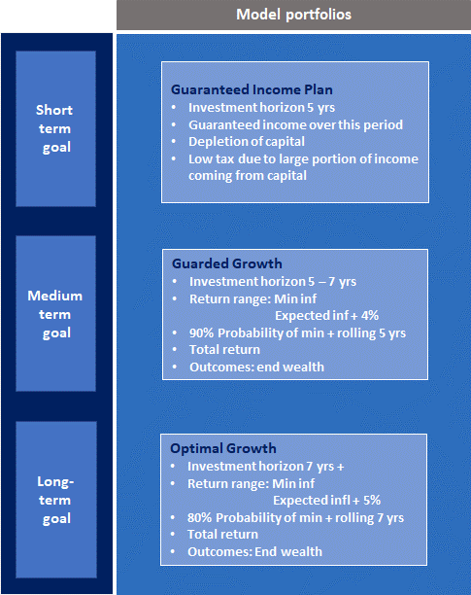

Projections

The projections for the living annuity capital will be the same in this option as indicated under option 1.

The graphs for the discretionary capital were based on the following allocation assumptions:

Five years’ income is placed in a guaranteed income plan, with an additional allocation of the travel allowance, possible shortfall in income increases for 5 years and annual allowance for income tax on discretionary capital of R300 000 being invested in a Stable Income portfolio.

The capital that will be needed to take out a new guaranteed income plan after 5 years is invested in a Guarded Growth strategy, while the rest of the portfolio can be structured for long term growth.

The table below indicates the allocation used for the discretionary capital. Bear in mind that each 5 years, new capital will be used to take out a new guaranteed income plan. The assumptions made around the guaranteed plan is that the same amount of capital will be used in 5 years’ time to take out a new plan (R5 265 984), plus additional provision of about R735 000 for tax, adjusted with inflation over time.

Solution | Years’ income/ allocation % | Yield %  (after advice & platform fees
Guaranteed income plan | 5 yrs. income
Stable income | 5.00% | 6.57
Guarded growth | 25.00% | 8.57
Optimal growth and offshore | Balance | 9.57

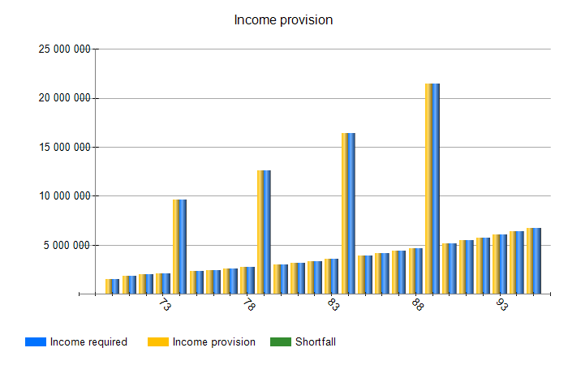

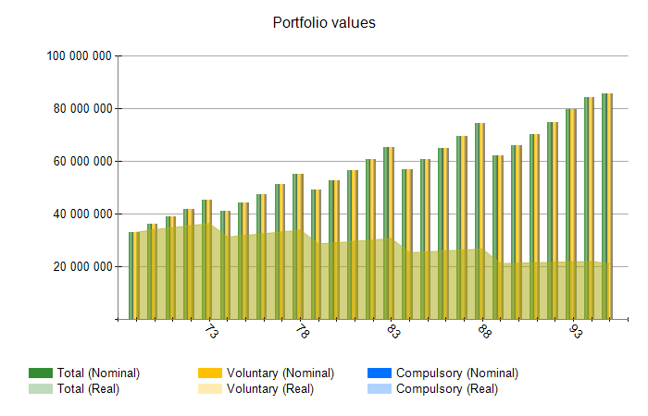

Cash flows are attached separately.

Allocation to solutions

The tables below set out the allocation to each solution in both option 1 and 2. The asset allocation for the complete portfolio is also included. Bear in mind that where existing endowments are still within the restricted period, these can be kept and just structured according to the proposed strategy.

Option 1 – Bucket approach using outcomes based solutions

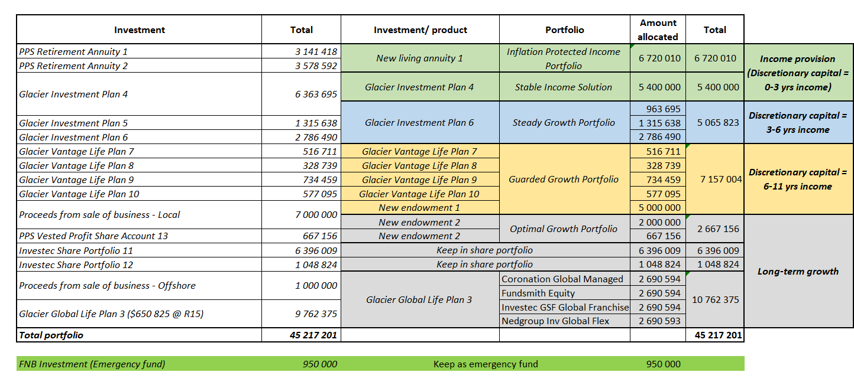

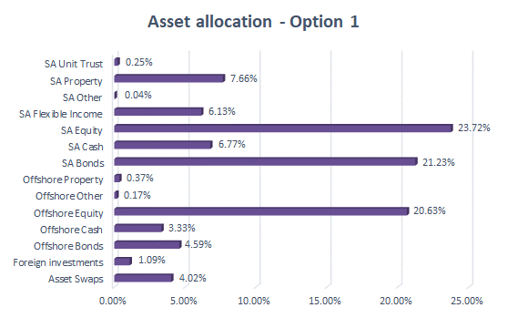

Option 2 – Bucket approach with guaranteed income plan

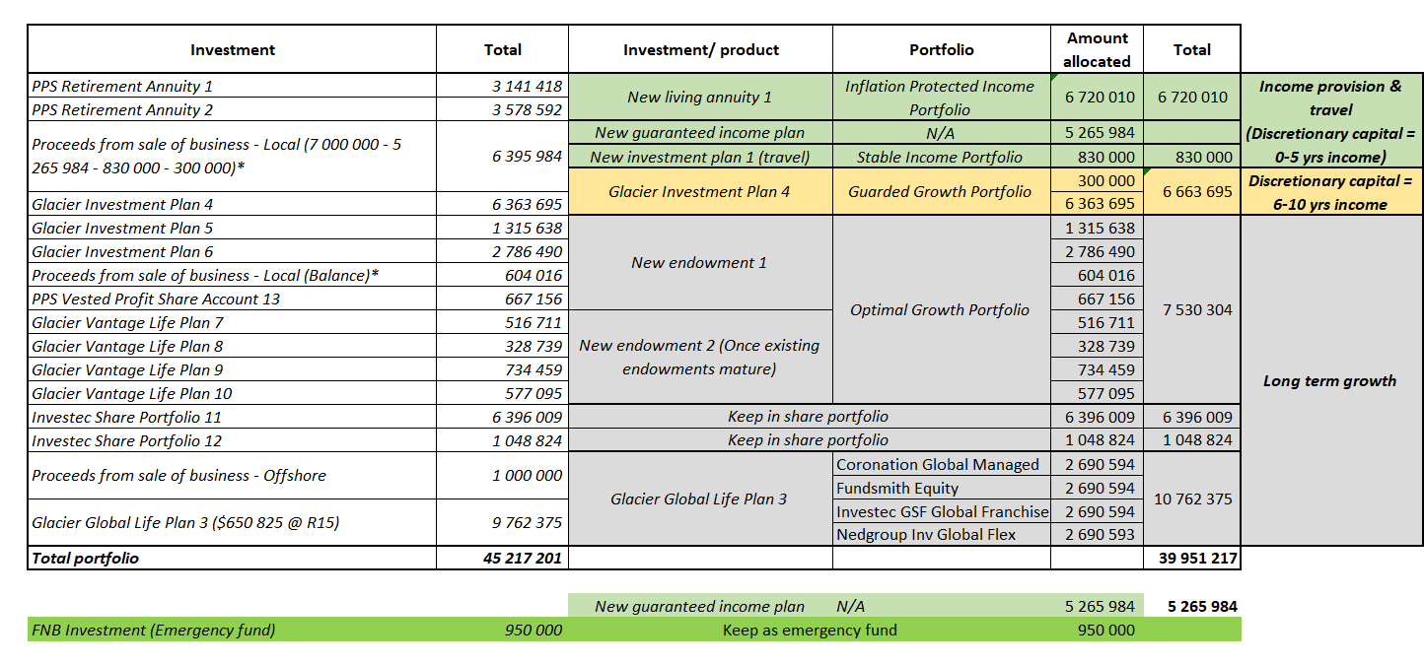

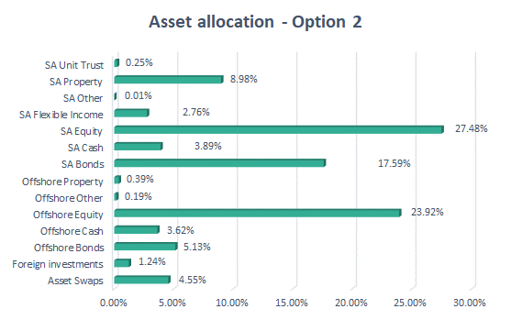

Breakdown and risk information on solutions

The graphs below indicate the best and worst returns for the income solutions (Inflation Protected Income solution and Stable Income solution) over various time periods. For the Inflation Protected Income solution these figures are based on the strategic asset allocation. A strategic allocation is the allocation that is required to reach the specified objective. The underlying assets of the strategic allocation is represented by each asset class’ relevant index. For the Stable Income portfolio, the figures are based on the best & worst returns of the underlying funds used in the portfolio.

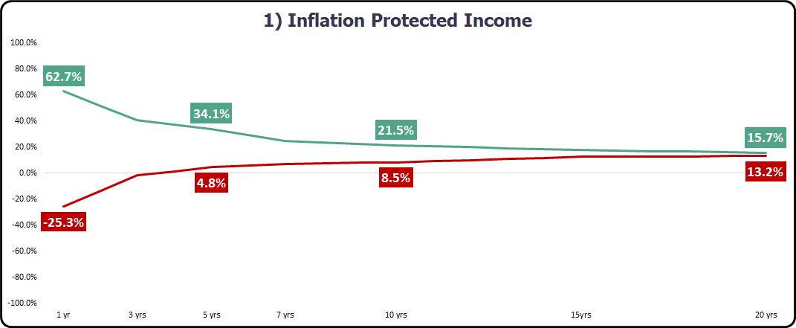

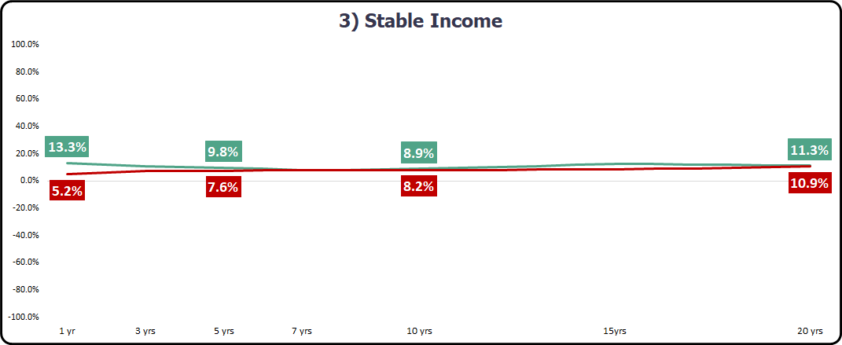

The illustration below for the Steady Growth, Guarded Growth and Optimal Growth strategies set out the number of times the strategy produced the outcome over a rolling period of time. The Steady Growth illustration is based on a rolling 3-year period, the Guarded Growth over a rolling 5-year period and the Optimal Growth over a rolling 7-year period.

Steady Growth

Guarded Growth

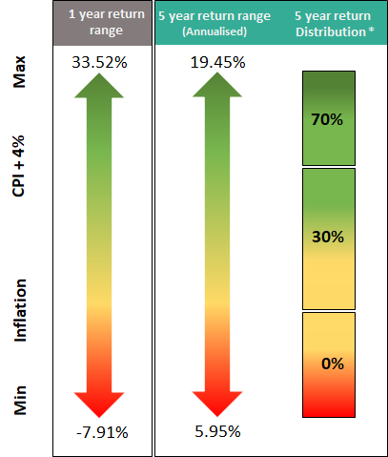

Optimal Growth

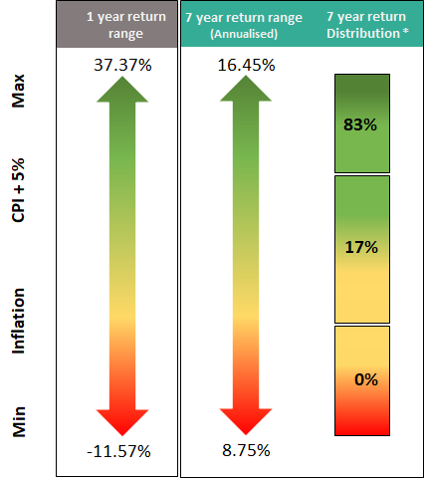

On the proposed offshore portfolio, the graph below sets out the risk/ return of the proposed portfolio against the existing offshore allocation over a 5-year period. Although the risk of the proposed portfolio is higher, one is compensated well for the additional risk taken, and as the idea for this capital is long term growth, it is not expected that capital is needed from this portfolio for at least 10 years. We have also included a table indicating the best & worst returns for the proposed funds (in rand terms) since inception or the last 10 years (from 01/04/2010 to 31/03/2020) if inception was prior to 2010.

FUND | MIN | MAX
Coronation Global Managed A | -7.18% | 49.36%
Fundsmith Equity I Acc | -5.08% | 57.79%
Investec GSF Glb Frchs I Acc USD | -10.95% | 46.34%
Nedgroup Inv Funds Global Flex A USD Acc | -6.54% | 42.30%

See attached fund fact sheets for more information on each of the solutions proposed under options 1 and 2. The following fact sheets are included:

- Inflation Protected Income
- Stable Income
- Steady Growth
- Guarded Growth
- Optimal Growth
- Direct offshore funds

Additional info and alternative strategies

While care has been taken to use reasonable assumptions in the proposal, it is important to remember that there are a lot of factors that can affect the outcome and sustainability of the income. Figures provided can therefore not be guaranteed.

If we consider the two options illustrated in the proposal, one of the arguments in favour of using a guaranteed income plan, is that the current economic climate is uncertain due to the outbreak of Covid-19, and we may be faced with a new normal going forward. Using a guaranteed income plan, at least for the first 5 years, will give some certainty with regards to your income, while things get a chance to settle down. After the first 5 years, you can then decide if you want to switch over to option 1.

Another advantage of a guaranteed income plan is the low tax that is levied. This is due to the fact that a big portion of the income paid consists of capital, therefore section 10A of the Income Tax Act apply. (Refer to quote for additional requirements for section 10A to apply.) Should you decide to rather invest the first 6 years’ income in the Stable Income solution and the Steady Growth portfolio, the tax will be paid on the distributions received on the total investment value in these solutions. (More information on the tax is set out in section 8.)

You will notice in both options that the money set aside for medium to long term growth is invested in endowment structures. These structures are proposed as tax within an endowment is levied at a flat rate 30%. This is then deducted from your investment value and paid over to SARS by Glacier (the administrative company). This means that any pay outs to you from the investment is net of tax.

Unfortunately, withdrawals from endowments are limited to one withdrawal within the first 5 years. Therefore, if you want to create a measure of liquidity while using endowments, an option is to divide the capital in five different plans so that you can make at least one annual withdrawal from each plan.

Additional options

The options set out in the proposal are not the only options available and other possible strategies can include making use of income solutions only to meet your income needs. This strategy can be applied in two ways:

- By investing the capital required to provide in your income needs in local income solutions only. At the current rates all your local capital will need to be placed in the Inflation Protected Income solution and you may need to bring back some of the offshore capital to fund additional needs like the travel expenses, shortfalls in income increases etc.
- By investing all your local discretionary capital as well as your living annuities in the Inflation Protected Income Solution and then also structuring a portion of your offshore discretionary capital for income, making use of similar offshore income type strategies.

When using the above strategies, the idea would be to preserve your capital in real terms. This also means that your entire portfolio will be invested in one or two solutions. Also bear in mind that it will be very important to set enough capital aside for emergencies as ad hoc withdrawals will have an impact on the income being generated in the portfolio.

Projections for these scenarios can be done on request.

Tax considerations

Given your sizeable portfolio and current income level, you fall in the highest income tax bracket and the proposed solutions therefore aim to reduce your tax where possible.

Income tax

The voluntary capital can earn interest, dividends and capital gains. Dividends are currently taxed at a flat rate of 20% and is usually withheld by the company paying the dividends or the investment administration company before it is paid over to the client. Persons over the age of 65 get an annual interest exemption on local interest earned to the value of R34 500. Any interest earned above this amount, as well as foreign interest earned, will be added to other sources of income and taxed at your marginal rate. Any withdrawals or switches made within voluntary investments (this excludes withdrawals or switches from money market funds) may have a capital gains tax implication. This will also apply to restructuring of the portfolio. Individuals currently get an annual exclusion of R40 000 on capital gains.

If the capital is invested in a guaranteed income plan, the tax deducted from the income will be fairly low, as the biggest portion of the income will consist of capital being drawn. Any capital not required for the first five years can be invested in endowment plans, where tax is levied at a fixed rate of 30%, which is deducted from the investment value and paid to SARS by the administration company. This means that any capital paid to you, will already be net of tax.

If capital is invested in a living annuity, no tax will be paid on the interest or dividends received in the product nor on any capital gains realized. Any withdrawals made from your living annuity will be added to your other sources of income and taxed at your marginal rate.

Note that the initial restructuring of the portfolio will have a capital gains tax implication.

Estate duty

Voluntary investments will form part of your assets for estate duty purposes, but individuals currently get an exemption of R3 500 000 before estate duty of 20% is levied on your dutiable estate. (Values above R30 million will be taxed at 25%)

Compulsory products (retirement annuities, pension funds, provident funds, preservation funds or living annuities) are exempt from estate duty but note that contributions made to retirement products which could not be deducted, claimed against your lump sum on retirement or claimed against income after retirement, will be included in your estate.

Any bequest made to your spouse will be free from estate duty but will then be included in their estate.

Fees

The fees on your portfolio are as follows:

 | Initial fee (once off) | Annual fees
Advisor | 0.0% | 0.58%
Administration (LISP) | 0.0% | 0.35% estimate (see quotation)
Fund manager | 0.0% | See fund fact sheet (TER)
DIM fee | 0.0% | 0.23 – 0.29%
Note: Fees include VAT

